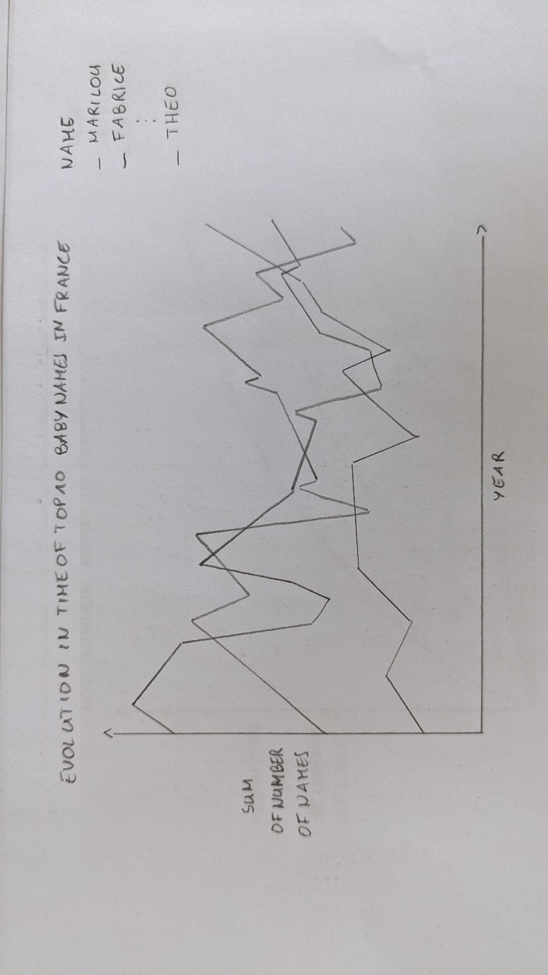Visualization 1

How do baby names evolve over time? Are there names that have consistently remained popular or unpopular? Are there some that have were suddenly or briefly popular or unpopular? Are there trends in time?

This visualization demonstrates the evolution of France's Top 10 Baby Names from 1900 to 2020. Each of the top 10 baby names has a curve in the legend that shows how the number of babies with that name has changed over time.

Pros: By concentrating on fewer data points, this style has the advantage of making the graphs easier to read.

Cons: Only displaying the top 10 names omits the popularity of these baby names. To have something to compare with, it would be beneficial to have information about various baby names. Because the curve can overlap, another thing to do would be to utilize colors to make it easier for people to instantly identify the curve with baby names. The goal of this sketch's implementation is to employ animation so that the user can more easily perceive how a selected curve changes over time.

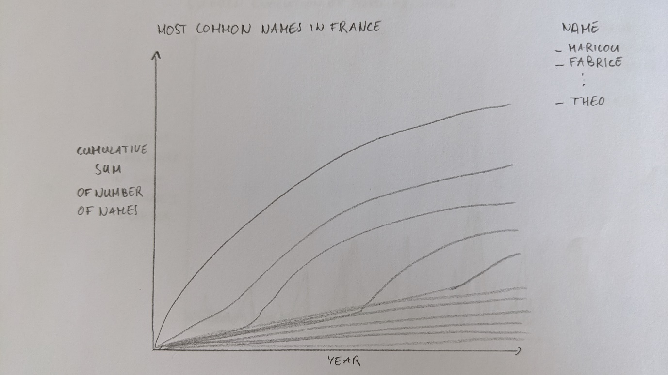

This visualization aims to display the most popular baby names in France. Each baby name in the legend includes a curve that shows how the cumulative total of all the babies who have that name has changed over time in terms of years.

Pros: The advantage of this representation is that it demonstrates the popularity of certain names in France. Additionally, it might reveal when a name started to become more popular.

Cons: For baby names that are uncommon, showing all the info may make it impossible to read. Of course, adding colors may still be crucial to enable users to instantly connect the curve to baby names. The goal of this sketch's implementation is to employ animation so that the user can more easily perceive how a selected curve changes over time.

This visualization aims to demonstrate the abrupt evolution of both popular and uncommon baby names in France from 1900 to 2020. Each baby name has a curve in the legend reflecting the percentage change in the number of infants with that name between the current year and the year before.

Pros: Because the peaks demonstrate a significant difference in the number of babies given this name compared to the previous year, this representation has the advantage of showing names that have undergone quick evolution. Because fewer parents have given their kids this name after the peak end, it may also be used to demonstrate how quickly these trends changed.

Cons: Displaying all the information may make baby names that aren't suddenly popular unintelligible. Of course, adding colors may still be crucial to enable users to instantly connect the curve to baby names. In terms of the trend, this graph only depicts a trend over a single year, but by constructing bins of ten years and adding the number of baby names ten years by ten years, it could be feasible to discern a pattern across decades. The goal of this sketch's implementation is to employ animation so that the user can more easily perceive how a selected curve changes over time.